**AFM and TACACS Configuration**

1. Introduction:

This is document on how to setup tacacs server and use it from AFM

1. TACACS+ server setup in Debian:

Make sure tacacs server is up and running and responds to the authentication request.

If NOT, please follow the steps below to install and setup tacacs+ server on a fresh Debian server

1. Execute the following command as root user to install tacacs+ server

apt-get install tacacs+

1. If you want to use Linux users for authentication then uncomment the following line in /etc/tacacs+/tac_plus.conf:

default authentication = file /etc/passwd

1. Re-start tacacs+ server using the below command

service tacacs_plus restart

Please set up required Linux user account on the tacacs server using the below commands.

1. useradd <username>
2. passwd <username> (while prompting for password, enter a password)

Following default users should be set on the tacacs server with any password

1. Username : **root**
2. Username : **afm**
3. Username : **superuser**

The default switch access should also be created on the tacacs server with the following credential

Username: **admin**

Password: **admin**

1. TACACS+ client setup in AFM server

From AFM console select the option “TACACS Setup” to install tacacs+ client in AFM.

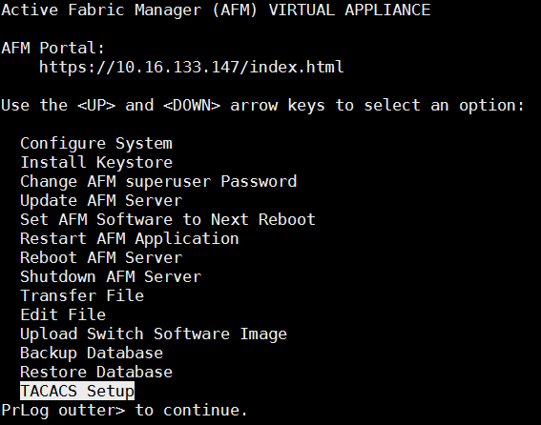

1. Configure Tacacs in AFM server

From Administration 🡪 Settings 🡪 “Authentication Settings” choose “Local followed by TACACS” and provide tacacs server ip address, port (49) and server key.

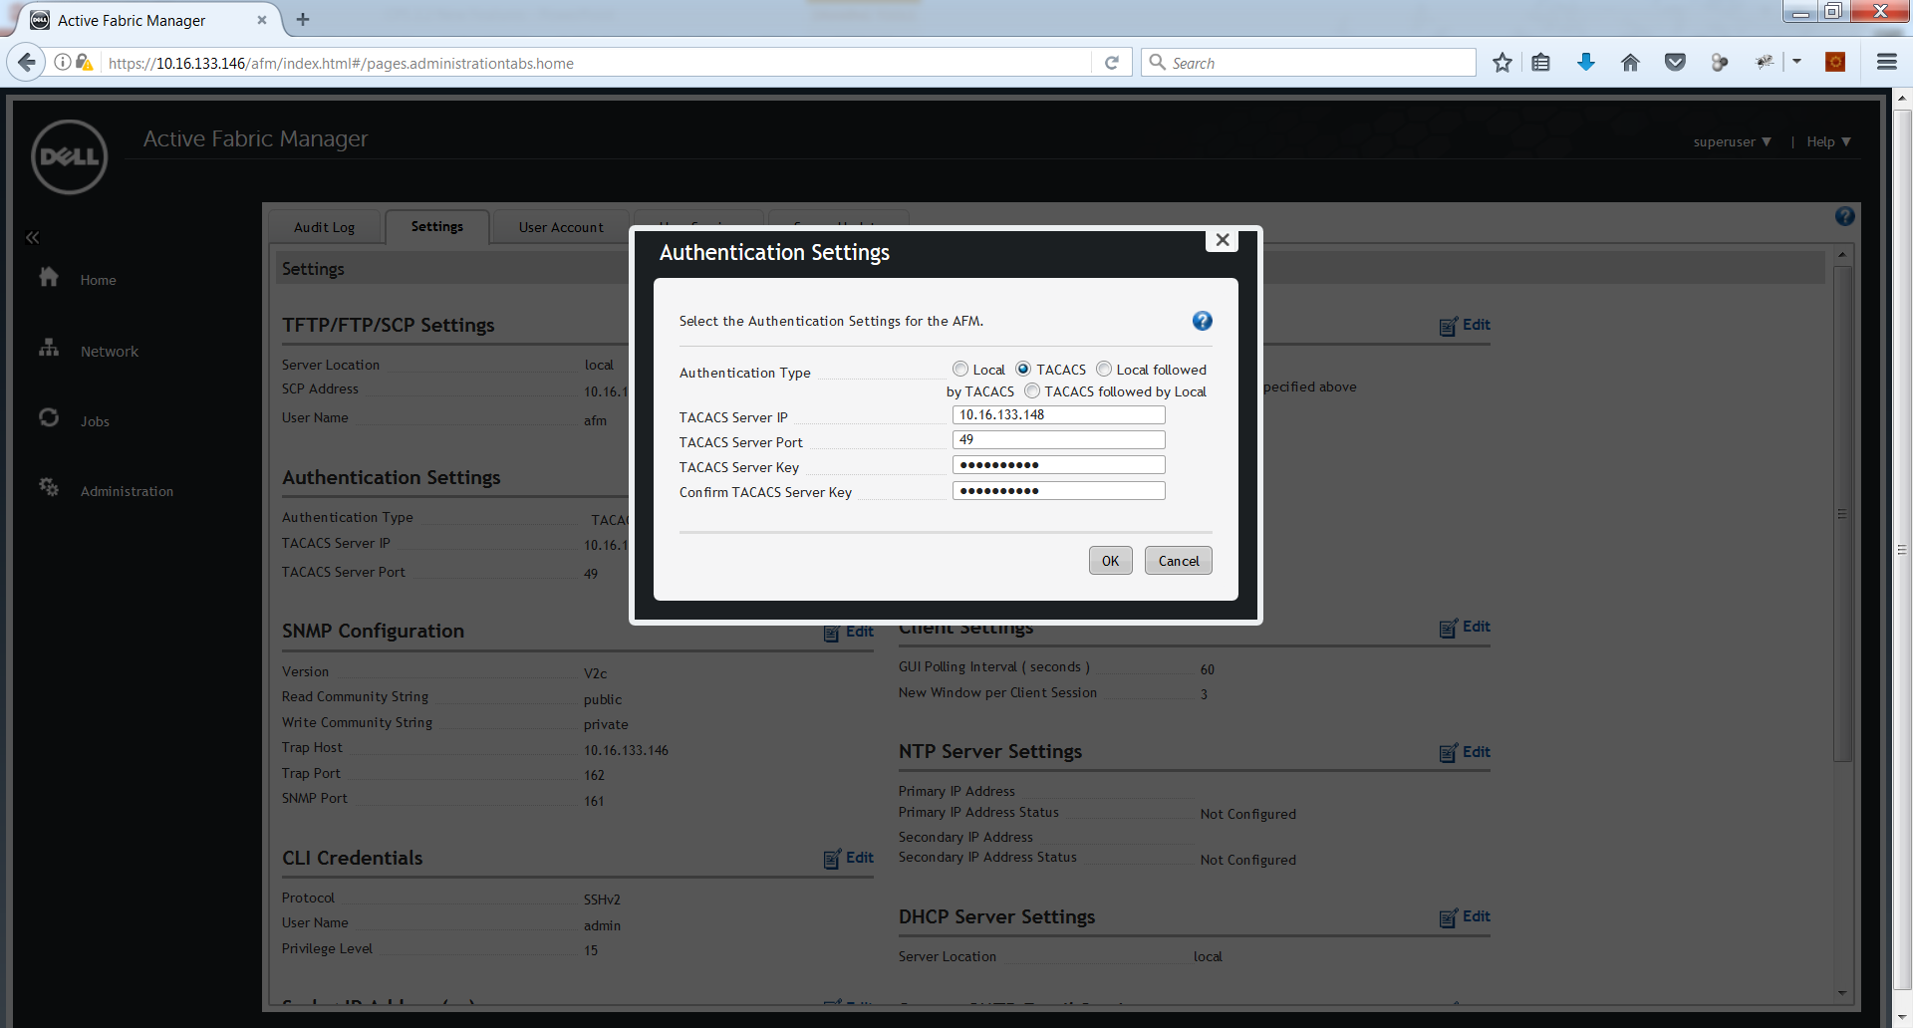

From Administration 🡪 “Audit Log” Make sure tacacs is working for AFM logins.

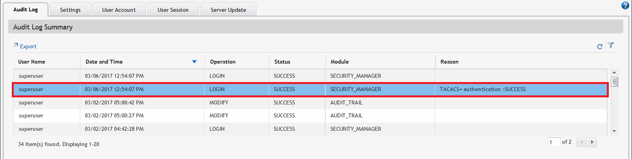

Once it is verified change the option from “Local followed by TACACS” to “TACACS”

1. Tacacs+ authentication for switches

Set up tacacs server for device authentication in the pre-deployment wizard.

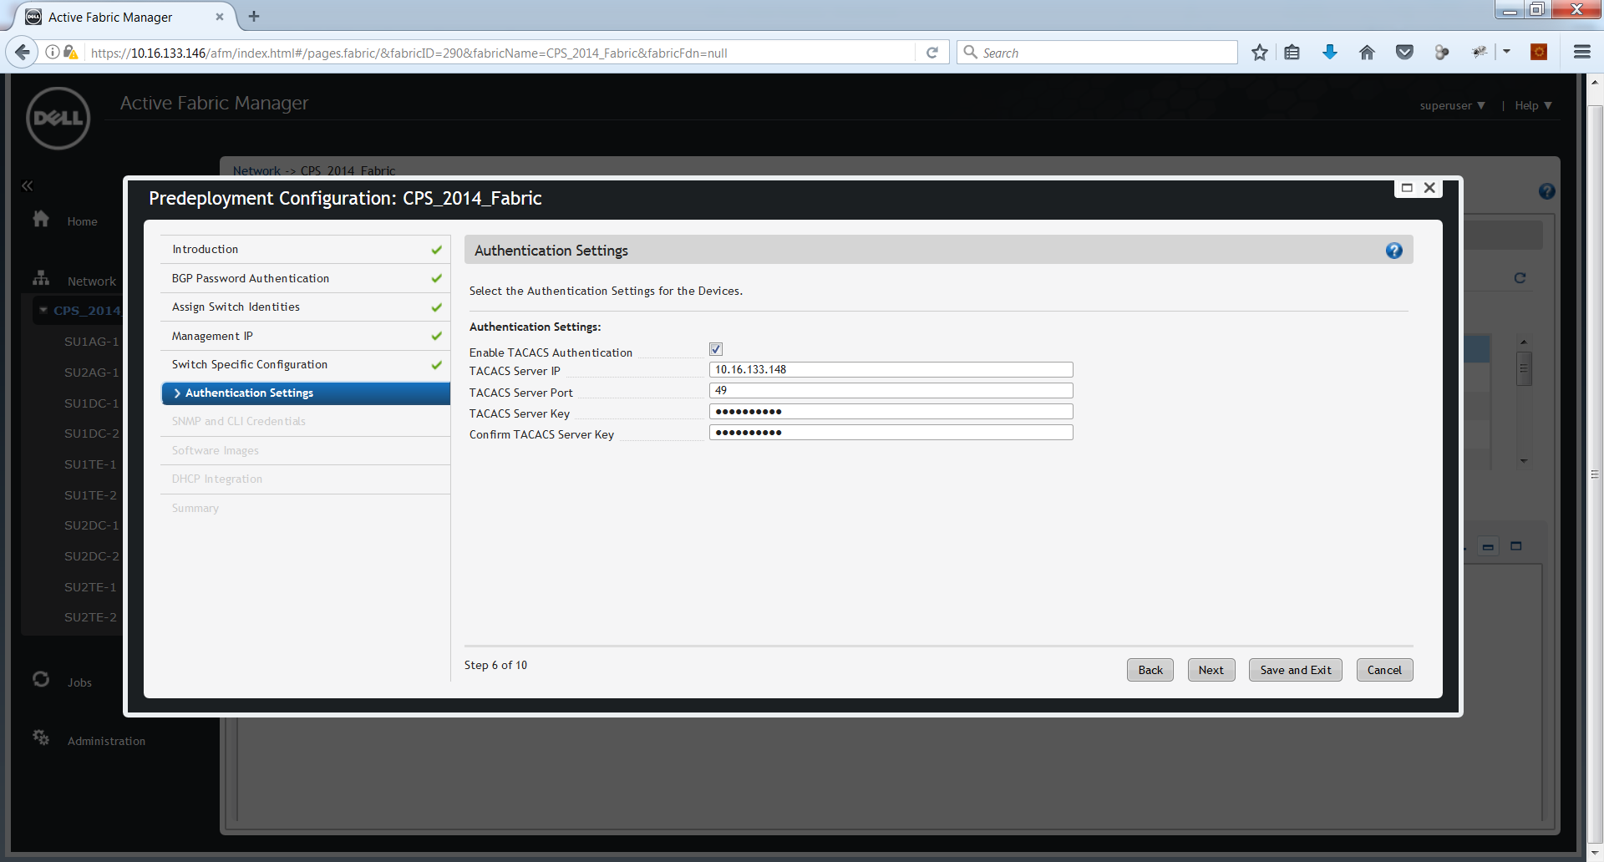

--The End--